Shen Wei
Between Blossoms (02.09-09.10.2017)

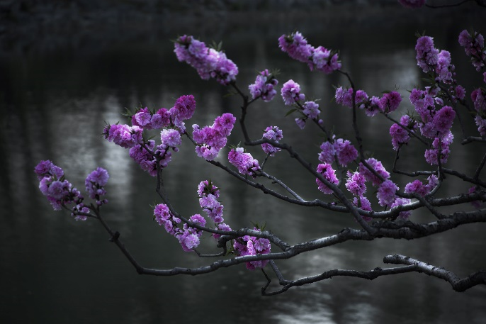
“Between Blossoms is inspired by my dreams of the unknown and by the mysteries that fascinate me. I find these fantasies hinted at in the reality that surrounds me; a touch of melodrama here, a hint of seduction there, which enhances the everyday with an elusive, enchanting beauty.”
- Shen Wei
In his photographic series Between Blossoms, New York-based Chinese photographer Shen Wei has taken a meditative journey across continents, from the United States to Europe and Asia. His seductive photographs capture a unifying sense of other-worldliness within the changing landscape, generating an abstracted sensation of place that he describes as “deeply connected to my inner melancholy, a dream-like state of mind.”

The images in Between Blossoms bind the influence of traditional themes of Chinese art, drawn from the natural environment, with the ancient Chinese philosophy of Qi. Shen Wei’s attention to the interactions of darkness and light, and negative or void spaces gives these hidden forces tangible form, drawing from the philosophical treatment of emptiness as solid space often found in Chinese painting. This can be seen in the near pitch-black void within Peach Tree, from which a lush, flower-studded tree emerges, and the dynamic energy within the central light-filled cavity in Monkey. The interplay of positive and negative elements also articulates oppositional emotional states of fear, attraction, joy, loneliness and absence.

Shen Wei’s immersion in the landscape during his travels has led to a focus on vegetal subject matter, with trees acting as a thread interwoven throughout the series. In Chinese culture, each tree has a symbolic meaning (Shen Wei notes that the peach tree represents seduction and love), corresponding with Wei’s own instinctive evocation of feeling in nature, which he has characterized as “both specific and spontaneous”. Shen Wei’s method of image-making involves extended periods of waiting for the perfect light or sense of movement (for instance the glowing morning light in House Frame), the meditative process itself becoming a crucial component of the work.

The nude self-portraits in Between Blossoms add a reflexive dimension, evoking inner moods or sentiments, with less emphasis on the physical body than in the past. While previous series’ (such as I Miss You Already) have explored notions of intimacy, desire, and identity through the human form, recent images such as Searching reflect on the subconscious relationship between the body and its environment, with harmoniously balanced compositions that both cloak and reveal the figure, invoking a mystical state or ghost-like presence.

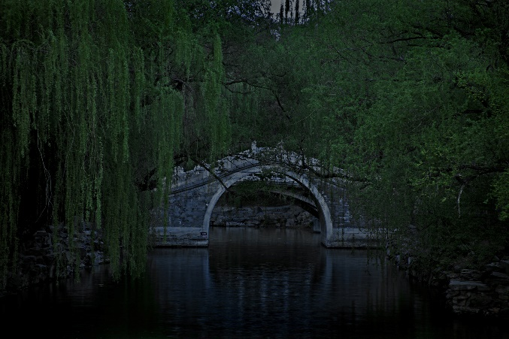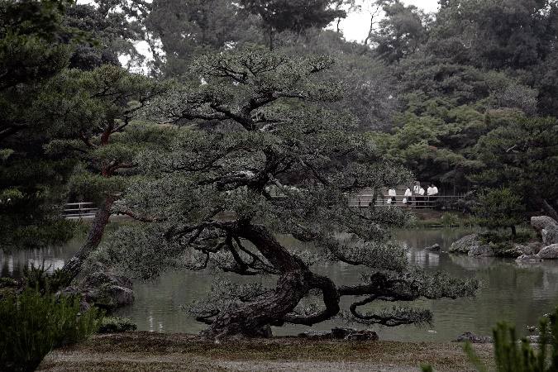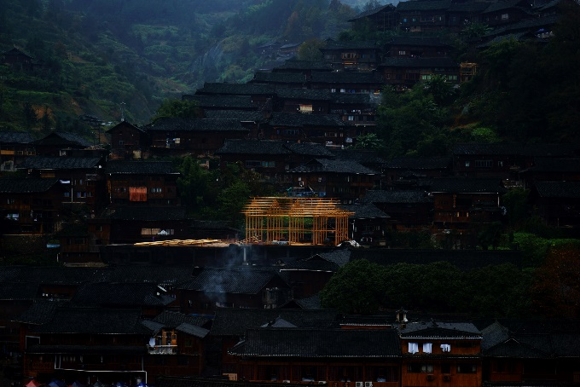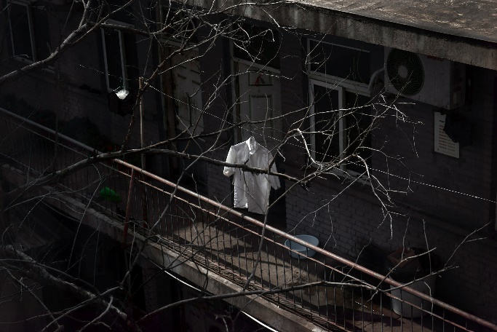

Born and raised in Shanghai, Shen Wei is an artist based in New York City and Shanghai. His work has been exhibited internationally, with venues including the Museum of the City of New York, the Philadelphia Museum of Art, the Power Station of Art in Shanghai, La Triennale di Milano, the North Carolina Museum of Art, and the Moscow Museum of Modern Art. His work has been featured in The New Yorker, The Guardian, CNN, Aperture, ARTnews, American Photo, China Photo Press, and Wall Street Journal.

Shen Wei’s work is included in the permanent collection of the Museum of Modern Art (MoMA), the Philadelphia Museum of Art, the J. Paul Getty Museum, the Museum of Contemporary Photography, the Library of Congress, the Carnegie Museum of Art, the Museum of Chinese in America, and the Ringling Museum of Art, among others.

Shen Wei is a recipient of the Rockefeller Foundation Bellagio Center Arts Residency, the Asian Cultural Council Arts & Religion Fellowship, the New York Foundation for the Arts Fellowship, and the Lower Manhattan Cultural Council Arts Grant. He holds an MFA in photography, video, and related media from the School of Visual Arts, New York; and a BFA in photography from Minneapolis College of Art and Design.

Solo Exhibitions:
2017
Flowers Gallery, Between Blossoms, New York, NY
Visionairs Gallery, Invisible Atlas, Singapore
2016
Galerie Christophe Tailleur, Dusk of the Harmonious Garden, Strasbourg, France
2015
Flowers Gallery, Invisible Atlas, New York, NY
2014
H Gallery, I Miss You Already, Bangkok, Thailand
2013
LA. Galerie Lothar Albrecht, Chinese Sentiment, Frankfurt, Germany
2012
Daniel Cooney Fine Art, I Miss You Already, New York, NY
Light Work, I Miss You Already, New York, NY
Epson Imaging Gallery, Chinese Sentiment, Shanghai, China
Monika Olko Gallery, Chinese Sentiment, Sag Harbor, NY
Athens Photo Festival 2012, Chinese Sentiment, Athens, Greece
2011
Daniel Cooney Fine Art, Chinese Sentiment, New York, NY
Art Institute of Boston, Chinese Sentiment, Boston, MA
Chinese American Arts Council, Almost Naked, New York, NY
Lumenvisum, Chinese Sentiment, Hong Kong, China
2009
Randall Scott Gallery, Almost Naked, New York, NY
2008
Kunst Licht Gallery, Almost Naked, Shanghai, China
Chinese American Arts Council, Concubines of New York, New York, NY
2006
Elkins Gallery, Almost Naked, Temple University, Philadelphia, PA
2004
Chinese American Arts Council, Concubines of NY, New York
2003
TIXE Gallery, Behind the Persona, New York, NY

Collections:
Museum of Modern Art (MoMA), New York, NY
Philadelphia Museum of Art, Philadelphia, PA
The J. Paul Getty Museum, Los Angeles, CA
Museum of Contemporary Photography, Chicago, IL
Library of Congress, Washington, D.C.
Ringling Museum of Art, Sarasota, FL
Carnegie Museum of Art, Pittsburgh, PA
Museum of Fine Arts, St. Petersburg, FL
North Carolina Museum of Art, Raleigh, NC
He Xiangning Art Museum, Shenzhen, China
Florida Museum of Photographic Arts, Tampa, FL
Griffin Museum of Photography, Winchester, MA
Southeast Museum of photography, Daytona, FL
Museum of Chinese in America, New York, NY
Harn Museum of Art, Gainesville, FL
Rockefeller Brothers Fund, New York, NY
C. V. Starr Foundation, New York, NY
Kinsey Institute, Indianapolis, IN
Light Work Permanent Collection, Syracuse, NY
London Economics Corporate Collection, Toronto, Canada
United Airlines Corporate Collection, Chicago, IL
Target Corporate Collection, Minneapolis, MN
Agnes Gund Collection, New York, NY
Allen G. Thomas Jr. Collection, Wilson, NC
Jonathan F. Fanton Collection, New York, NY
William K. Zewadski Collection, Tampa, FL
John J. Studzinski Collection, New York / London

